**Realistic Modeling of the Complex Morphology of CNT-Reinforced Nanocomposite using Immersed Finite Element Simulations**

X. Chen, A.R. Alian and S.A. Meguid*

*Department of Mechanical & Industrial Engineering, University of Toronto, Toronto, Canada*

**Abstract**

It is very challenging to perform continuous meshing of highly densed CNT-reinforced composites due to the extremely high aspect ratio and complex morphologies of the nanotubes. These difficulties are typically overcome by simplifying the structure and using reduced cell size which results in inaccurate predictions. In this article, we overcome these major limitations in traditional finite element (FE) method by using unmatched meshing in immersed FE method, in which the composite constituents are meshed independently but simulated as a coupled system. The most important advantage of the newly developed method is that the polymer can always be discretized as a regular grid, irrespective of the complex nature of the CNT network, while still strictly obeying the equilibrium equations of the fully bonded CNTs and the matrix. The developed modeling approach allowed us to simulate realistic representative volume elements filled with randomly dispersed CNTs of different curvatures, orientations, and aspect ratios. The numerical examples demonstrate that the results of the Immersed FE method are very close to those obtained by the traditional FE method. Finally, the developed technique is used to determine the effect of CNT morphology and volume fraction on the mechanical properties of polymeric nanocomposites.

**Keywords:** Immersed finite element method, mechanical properties, carbon nanotube, polymer, nanocomposites, morphology.

1. Introduction

Carbon nanotubes (CNTs) have attracted considerable interest due to their remarkable mechanical [1–4], electrical [5–7], and thermal properties [5,8]. These superior properties make CNTs an ideal choice as a reinforcement for multifunctional polymer-based nanocomposites [9,10]. Intensive attentions are paid to understand the mechanical behavior of the nanocomposite through experimental [7,11,12], analytical [13–15] and numerical studies [16–19].

Numerical simulation is widely used in studying the mechanical properties of nanocomposites and a variety of modeling methods are developed for different scale of interest [20–23]. Molecular dynamics (MD) technique is suited for investigating the nanoscale properties [24], where the constitutive relations are governed by the interatomic potential [25]. MD simulations can monitor the details of every atom, allowing researchers to study complex phenomena such as interfacial properties between a single nanotube and the surrounding matrix [25–27], effect of chemical functionalization on structural stability and strength of CNTs [28,29], and influence of defects on CNT properties [18,30]. Several studies tried to utilize the increasing computational resources to conduct large atomistic simulations of composite systems [16,31,32]. The main objective was to simulate RVEs large enough to capture the actual nanocomposites microstructures [16]. However, even with the usage of the most advanced supercomputers, only ~ ${\text{10}}^{\text{9}}$ atoms, i.e. 1000 atoms in each direction, can be simulated; making it unsuitable approach to investigate microscopic composite systems reinforced with nanotubes of larger diameters and aspect ratios [33].

To enlarge the simulation scale, traditional continuum techniques were introduced which assume the material to be homogeneous and neglect the details of its atomic structure. Although the traditional continuum models cannot accurately describe the phenomena in nano-scale, it is able to provide valuable information to study the influences of the micro-scale parameters on the material properties of CNT-reinforced composites, such as the curvature [34–36], aspect ratio and volume fraction of the dispersed CNTs [37].

Both micromechanics and finite element methods were used to model nanocomposites at the microscale level and determine their effective bulk properties [38,39]. For example, Mori-Tanka micromechanical technique [40] has been used extensively in the literature to scale up the nanoscale properties of nanocomposites and evaluate the effect of morphological, dispersion state, and alignment on their overall performance [13,39,41]. However, such analytical techniques suffer from several drawback that results in unrealistic predictions of the properties of the material due to their inherent simplifications and limitations [16]. For instance, very low concentrations of CNTs were assumed in these analytical models [42]. Besides, the interactions between the reinforcements were neglected and all nanotubes were assumed to be of the same type, length, size, morphology, agglomerate size, and fully coupled to the matrix [39]. As a consequence, micromechanics models overestimate the properties of the composites and could not model RVEs representing the actual microstructure as imaged by electron microscopic techniques [16].

On the other hand, several research groups used finite element technique to overcome the aforementioned limitations in micromechanics technique by modeling RVEs reinforced with CNTs [36,38,43,44]. However, due to the enormous computational cost associate with modeling systems containing large number of CNTs, these models were limited to RVEs reinforced with tens of CNTs that have relatively small aspect ratios [38]. Such small number of CNTs accounted for very small volume fractions and narrowed the scope of the investigations. Additionally, the preprocessing part of the analysis related to the meshing stage is very challenging for larger systems because the traditional FE method requires both CNTs and surrounding matrix grids to be matched with each other and meshed as one part. For example, Lusti and Gusev [37] created a FE model of straight CNT-reinforced composites by using a complicated three dimensional mesh generator. A lot of efforts were made to create these models but there were still many highly distorted cells which may decrease the accuracy of the results. Moreover, the number of degrees of freedom (DoF) is also very large. For example, the volume fraction of CNTs in Fig.1(a) is only 0.5%, but the composite is meshed with ${\text{2.16×10}}^{\text{7}}$ tetrahedral elements. Alian and Meguid [43] also used the traditional FE model to study the mechanical-electrical behavior of composites reinforced by straight CNTs, but due to the difficulties in the meshing process, the CNT volume fraction was only limited to 0.3% in their research.

More recently, the “embedded element technique” [36,45] is used to simplify the meshing process. The CNTs are meshed as beam elements and their DoF are embedded into the polymer by modifying the stiffness matrix of each polymer element. However, only kinematic relation between CNT and polymer is considered in this method while the more important issue, namely the interacting forces in between, are not accounted for. In summary, unnecessary simplifying assumptions are introduced to overcome the difficulties in the meshing process, and they will also decrease the accuracy of the results.

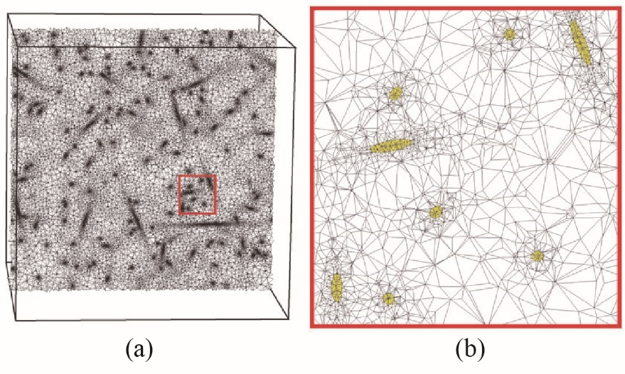 

(a) (b)

**Fig. 1.** Traditional FE models of composites reinforced with straight CNTs that were modeled with (a) linear tetrahedral elements (from Ref. [37]) and (b) beam elements (from Ref. [45]).

In this study, we adopt the immersed FE method that allows the dispersed CNTs and the polymer matrix to be meshed independently but simulated simultaneously as a coupled system. It means that the polymer can be discretized as a regular grid, irrespective of the complex nature of the CNT network. Using the developed technique, we managed to simulate realistic composite systems containing high concentrations of CNTs of different morphologies. A fully bonded interface was considered between the randomly distributed nanotubes and the surrounding matrix. Unlike the embedded element technique which embeds the degree of freedoms of the beam elements representing the distributed CNTs, the equilibrium equation of the 3D elements representing a CNT in our model is embedded into the equilibrium equation of the polymer according to the Newton's third law. Therefore, both kinematic and mechanic relations between the composite constituents are considered in the proposed immersed FE approach. The developed method is validated by comparing its results for different cases with those obtained with the traditional finite element simulations and then used to investigate the effect of volume fraction and waviness of CNTs on the mechanical properties of epoxy-based nanocomposites.

It should be mentioned that the developed immersed FE approach can utilized be model different particle-reinforced composites with complex fiber architectures and dispersion states. This model can also be coupled with electrical models to determine the electromechanical coupling of nanocomposites-based sensors.

1. Immersed finite element modeling procedure

The immersed FE model was developed in three consecutive steps, as shown in Fig. 2. A Monte Carlo based algorithm was developed to create RVEs reinforced with randomly dispersed CNTs (see Fig. 2(a)). The polymer cubic cell was then meshed with regular grid, as shown in Fig. 2 (b). The elements representing the CNTs network were then immersed into the polymer grid as illustrated in Fig. 2(c). These procedures replace the meshing step in traditional FE modeling that require matching nodes along the constituents’ interfaces and hence allow us to create composite models irrespective of its complex CNT distribution and thus, make it possible for us to simulate realistic composites containing complex CNT configurations. The basic idea, assumptions, governing equation and the solution scheme of the Immersed Finite Element are presented in the subsequent subsections.

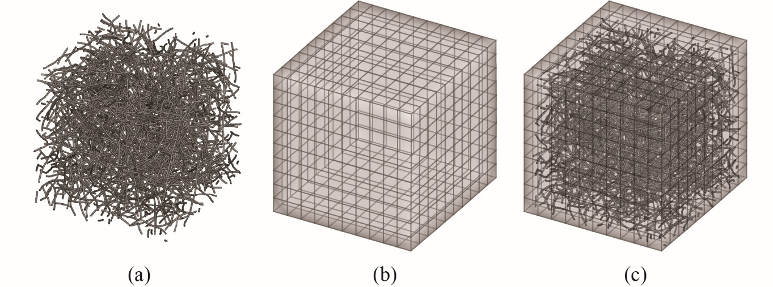

Figure.2: The flowchart of the immersed FE method.

* 1. Basic assumptions and governing equations

The polymer and the CNTs are meshed independently with 8-node hexahedral elements that are not matching at the constituents’ interface. The basic assumption is that the polymer and CNTs are fully bonded, i.e. the displacement of the CNT surface nodes are equals to the local polymer displacement. This assumption is widely used in continuum model [34,37,43,46] although the matrix and the CNT are actually bonded at the atomic scale with the relatively weak van der Waal's (vdW) Interaction [39]. This approximation of the interface leads to an overestimated material properties [47], specially at higher strain levels. However, it is also reasonable to consider a fully bonded coupling for small deformation where the stress in matrix can fully transferred to the embedded CNTs [48].

In the immersed FE method, the CNTs' grid are not matched with the polymer grid, so the displacement of the CNT surface nodes should be gathered from the surrounding polymer nodes. Once the surface displacement of the *i*th CNT, namely ${\text{d}}_{\text{i}}^{\text{ CNT,B}}$ is determined, the internal displacement ${\text{d}}_{\text{i}}^{\text{ CNT,} \text{I}}$ and the reacting force ${\text{f}}_{\text{i}}^{\text{ CNT, react}}$ can be obtained by solving the equilibrium equation:

$\left[\begin{matrix}{\text{K}}_{\text{i}}^{\text{ CNT,II}} & {\text{K}}_{\text{i}}^{\text{ CNT,IB}} \\ {\text{K}}_{\text{i}}^{\text{ CNT,BI}} & {\text{K}}_{\text{i}}^{\text{ CNT,BB}}\end{matrix}\right]\left[\begin{matrix}{\text{d}}_{\text{ i}}^{\text{ CNT,I}} \\ {\text{d}}_{\text{ i}}^{\text{ CNT,B}}\end{matrix}\right]=\left[\begin{matrix}\text{0} \\ {\text{f}}_{\text{ i}}^{\text{ CNT, react}}\end{matrix}\right]$ (1)

where ${\text{f}}_{\text{ i}}^{\text{ CNT, react}}$ is the force that the polymer applies on the *i*th CNT. The subscript “I” in Eq.1 means the active degree of freedom (DoF) in the system while the subscript “B” means the constrained DoF. Consequently, according to Newton's third law, the force that the *i*th CNT applies on polymer is $- {\text{f}}_{\text{ i}}^{\text{ CNT, react}}$. It should be mentioned that this force is not exactly applied on the polymer nodes, so it should be scattered to the surrounding polymer nodes. Since ${\text{d}}_{\text{ i}}^{\text{ CNT,B}}$ is calculated based on the polymer displacement ${\text{d}}^{\text{ Polymer}}$, the force that ${\text{CNT}}_{\text{i}}$ applies on the polymer should also be a function of ${\text{d}}^{\text{ Polymer}}$ and denoted as ${\text{F}}_{\text{i}}\left({\text{d}}^{\text{ Polymer}}\right)$. The polymer’s equilibrium equation can be written as follows:

${\text{K}}^{ \text{Polymer}} {\text{d}}^{\text{ Polymer}}\text{=}\sum_{\text{i}}{{\text{F}}_{\text{i}}\left({\text{d}}^{ \text{Polymer}}\right)}\text{+}{\text{f}}^{\text{ Polymer, react}}$ (2)

Equation (2) is the governing equation of the immersed FE method and the whole system can be determined by solving it.

* 1. Properties of the governing equation

In this section, we will prove that equation (2) leads to a linear equation with positive definite coefficient matrix. Suppose the number of DoF in the polymer grid is ${\text{N}}^{\text{ P}}$ and the number of the constrained DoF in the *i*th CNT is ${\text{N}}_{\text{i}}^{ \text{B}}$. ${\text{d}}_{ \text{ij}}^{\text{ CNT,B}}$ is the *j*th constrained DoF in *i*th CNT, which s gathered from the surrounding polymer nodes:

${\text{d}}_{\text{ ij}}^{\text{ CNT,B}}=\sum_{\text{k=}\text{1}}^{{\text{N}}^{\text{ P}}}{{\text{w}}_{\text{jk}}^{\text{d}\text{,i}}}{\text{d}}_{\text{k }}^{\text{ Polymer}}$ (3)

where ${\text{w}}_{\text{jk}}^{\text{d}\text{,}\text{i}}$ is the contribution of the *k*th polymer DoF to the *j*th constrained DoF of the *i*th CNT in the displacement gathering. Equation (3) can be rewritten as

${\text{d}}_{ \text{i}}^{\text{ CNT,B}}={\text{w}}_{\text{i}}^{\text{d}}{\text{d}}^{\text{ Polymer}}$ (4)

where ${\text{w}}_{\text{i}}^{\text{d}}$ is the displacement gathering matrix of *i*th CNT with dimension ${\text{N}}_{\text{I}}^{\text{ B}}×{\text{N}}^{\text{ P}}$. Accordingly, the solution of equation (1) is

${\text{f}}_{ \text{I}}^{\text{ CNT, react}}=\left(-{\text{K}}_{\text{I}}^{\text{ CNT,BI}}{\text{K}}_{\text{I}}^{ {\text{CNT,II}}^{\text{-1}}}{\text{K}}_{\text{I}}^{\text{ CNT,IB}}+{\text{K}}_{\text{I}}^{\text{ CNT,BB}}\right){\text{d}}_{ \text{I}}^{\text{ CNT,B}}={\text{T}}_{\text{i}}{\text{d}}_{ \text{I}}^{\text{ CNT,B}}$ (5)

where ${\text{T}}_{\text{I}}$ must be a positive definite matrix due the conservation of energy. Therefore, the force that the *i*th CNT applies on the polymer is

${\text{f}}_{ \text{I}}^{\text{ C2P}}=-{\text{T}}_{\text{i}}{\text{d}}_{ \text{I}}^{\text{ CNT,B}}$ (6)

This force should be scattered to the surrounding polymer nodes, as follows:

${\text{F}}_{\text{i}}={\text{w}}_{\text{i}}^{\text{f}}{\text{ f}}_{ \text{I}}^{\text{ C2P}}=-{\text{w}}_{\text{i}}^{\text{f}}{\text{T}}_{\text{i}}{\text{d}}_{ \text{I}}^{\text{ CNT,B}}$ (7)

where ${\text{w}}_{\text{i}}^{\text{f}}$ is the force scattering matrix with dimension ${\text{N}}^{\text{ P}}×{\text{N}}_{\text{I}}^{\text{ B}}$. Substituting equation (4) into equation (7), we have

${\text{F}}_{\text{i}}=-{\text{w}}_{\text{i}}^{\text{f}}{\text{T}}_{\text{i}}{\text{w}}_{\text{i}}^{\text{d}}{\text{d}}^{\text{ Polymer}}$ (8)

In this paper, the isoparametric interpolation of the 8-node hexahedral element is used to gather displacements and scatter forces. So ${\text{w}}_{\text{i}}^{\text{f}}={\left({\text{w}}_{\text{i}}^{\text{d}}\right)}^{\text{T}}$, and equation (8) can be rewritten as

${\text{F}}_{\text{i}}=\text{-}{\text{w}}_{\text{i}}^{\text{T}}{\text{T}}_{\text{i}}{ \text{w}}_{\text{i}}{ \text{d}}^{\text{ Polymer}}={\text{S}}_{\text{i}}{ \text{d}}^{\text{ Polymer}}$ (9)

where ${\text{S}}_{\text{i}}$ is a positive semidefinite matrix. Finally, substituting equation (9) into equation (2) gives

$\left({\text{K}}^{\text{ Polymer}}\text{+}\sum_{\text{i}}{{\text{S}}_{\text{i}}}\right){\text{d}}^{\text{ Polymer}}=\left(\text{K+S}\right){\text{d}}^{\text{ Polymer}}={\text{f}}^{\text{ Polymer, react}}$ (10)

$\text{K+S}$ is the total stiffness matrix of the nanocomposite which contains the original stiffness from the polymer, ***K***, and the reinforced stiffness from the CNTs, ***S***.

Strictly speaking, ***K*** should not be equal to the stiffness matrix of the pure polymer ${\text{K}}_{\text{0}}$. This is because the CNTs in the composite occupy some space of the polymer and thus, reduces the stiffness of the polymer. Nevertheless, since the volume fraction of the nanocomposite is very low (generally less than 5%), and the stiffness of CNT is much higher than that of the polymer (ECNT ≈ 3×102 Ep), the magnitude of $\text{K}-{\text{K}}_{\text{0}}$ should be much less than the magnitude of ***S***. Therefore, in this paper, ${\text{K}}_{\text{0}}$ is used in Eq. (10) for the sake of simplicity.

Dividing ${\text{d}}^{\text{ Polymer}}$ into the active DoF and the constrained DoF, equation (10) changes to

$\left[\begin{matrix}{\text{K}}^{\text{II}}\text{+}{\text{S}}^{\text{II}} & {\text{K}}^{\text{IB}}\text{+}{\text{S}}^{\text{IB}} \\ {\text{K}}^{\text{BI}}\text{+}{\text{S}}^{\text{BI}} & {\text{K}}^{\text{BB}}\text{+}{\text{S}}^{\text{BB}}\end{matrix}\right]\left[\begin{matrix}{\text{d}}^{\text{ I}} \\ {\text{d}}^{\text{ B}}\end{matrix}\right]=\left[\begin{matrix}0 \\ {\text{f}}^{\text{ react}}\end{matrix}\right]$ (11)

and the final equation about ${\text{d}}^{\text{ I}}$ is:

$\left({\text{K}}^{\text{II}} \text{+} {\text{S}}^{\text{II}}\right) {\text{d}}^{\text{ I}}=-\left({\text{K}}^{\text{IB}} \text{+} {\text{S}}^{\text{IB}}\right) {\text{d}}^{\text{ B}}$ (12)

It should be mentioned that ${\text{K}}^{\text{II}}$ is a positive definite matrix and ${\text{S}}^{\text{II}}$ is a positive semidefinite matrix, so the coefficient matrix of equation (12) is a positive definite.

* 1. Solution scheme

Although equation (12) is a linear equation, it is almost impossible to calculate the coefficient matrix directly because the expression of ${\text{S}}^{\text{II}}$ and ${\text{S}}^{\text{IB}}$ can be very complicated. However, $\text{Sd}$ can be easily obtained by solving equation (1) for each CNT and summing over all ${\text{F}}_{\text{i}}$. Therefore, the conjugate gradient (CG) iteration can be used to solve equation (12).

The flowchart of the CG iteration is shown in Fig. 3, where the values of ${\text{K}}^{\text{II}}\text{p}$ and ${\text{K}}^{\text{IB}}{\text{d}}^{\text{ B}}$ are known while ${\text{S}}^{\text{IB}}{\text{d}}^{\text{ B}}$ and ${\text{S}}^{\text{II}}\text{p}$ are unknown variables. Note that

${\text{Sd}}^{\text{ 0}}=\text{S}\left[\begin{matrix}\text{0} \\ {\text{d}}^{\text{ B}}\end{matrix}\right]=\left[\begin{matrix}{\text{S}}^{\text{II}} & {\text{S}}^{\text{IB}} \\ {\text{S}}^{\text{BI}} & {\text{S}}^{\text{BB}}\end{matrix}\right]\left[\begin{matrix}\text{0} \\ {\text{d}}^{\text{ B}}\end{matrix}\right]=\left[\begin{matrix}{\text{S}}^{\text{IB}}{\text{d}}^{\text{ B}} \\ {\text{S}}^{\text{BB}}{\text{d}}^{\text{ B}}\end{matrix}\right]$ (13)

so ${\text{S}}^{\text{IB}}{\text{d}}^{\text{ B}}$ equals to the components of ${\text{Sd}}^{ \text{0}}$ related to the active DoF. Similarly,

$\text{S}$ $\left[\begin{matrix}\text{p} \\ {\text{d}}^{\text{ B}}\end{matrix}\right]=\left[\begin{matrix}{\text{S}}^{\text{II}} & {\text{S}}^{\text{IB}} \\ {\text{S}}^{\text{BI}} & {\text{S}}^{\text{BB}}\end{matrix}\right]\left[\begin{matrix}\text{p} \\ {\text{d}}^{\text{ B}}\end{matrix}\right]=\left[\begin{matrix}{\text{S}}^{\text{II}}\text{p}+{\text{S}}^{\text{IB}}{\text{d}}^{\text{ B}} \\ {\text{S}}^{\text{B}\text{I}}\text{p}+{\text{S}}^{\text{B}\text{B}}{\text{d}}^{\text{ B}}\end{matrix}\right]$ (14)

so ${\text{S}}^{\text{II}}\text{p}$ equals to the components of $\text{S}$ $\left[\begin{matrix}\text{p} \\ {\text{d}}^{\text{ B}}\end{matrix}\right]$ related to the active DoF subtracting ${\text{S}}^{\text{IB}}{\text{d}}^{\text{ B}}$.

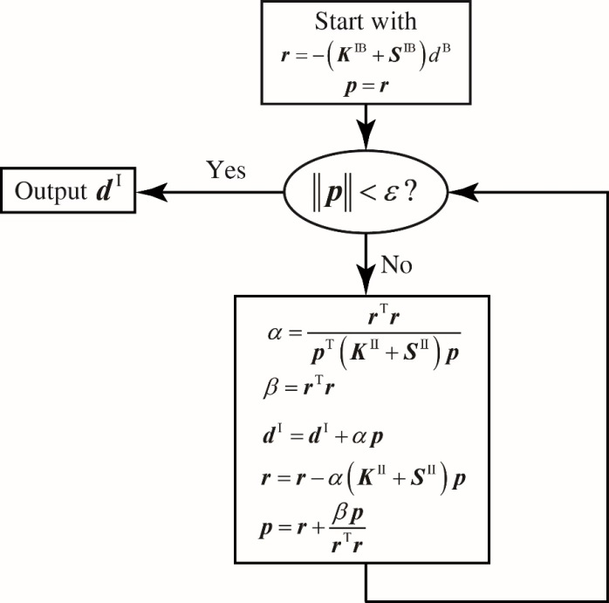

**Fig. 3.** A flowchart of the developed algorithm to perform CG iteration.

1. CNT network generator

In this section, we will introduce the Monte Carlo method to create the three dimensional straight and curved CNT networks in the RVE. This model is used to study the influence of the CNT waviness on the Young’s modulus of the composites.

The straight CNT can be characterized by a segment *A*1*A*2. *A*1 locates at a random position in the RVE and the orientation of the segment is randomly distributed. The length of the segment equals to the length of the CNT. Once *A*1*A*2 is determined, the corresponding cylinder is created to represent the CNT and discretized into hexahedral elements.

The curved CNT is characterized by a series of segments *A*1*A*2…*A*n. The length of each segment $∆l$ equals to $l_{CNT}/\left(n-1\right)$ and the angle between two adjacent segments is $∆θ$. The curved CNT is created segment by segment from *A*1*A*2. Fig.xxx shows the example of two adjacent segments *Ai*-1*Ai* and *AiAi*+1. Once *Ai*-1*Ai* is determined, *Ai*+1 should locate at a random position on the bottom edge of the cone.

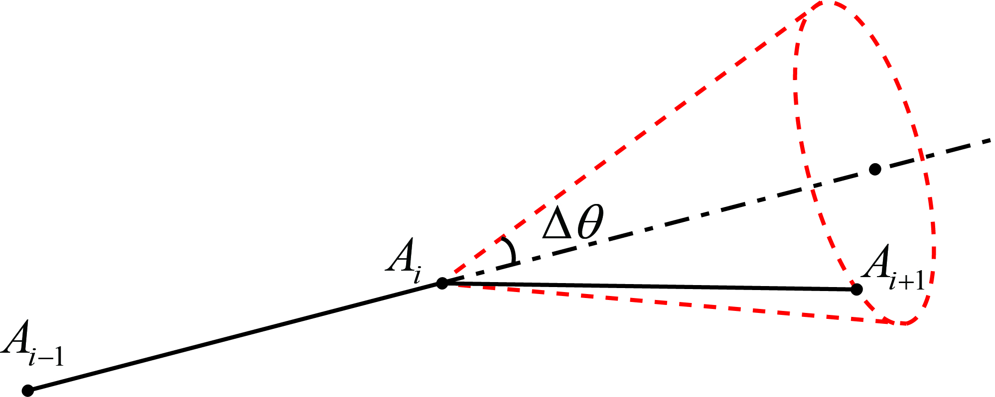

Fig.xxx. The adjacent segments in the curved CNT. The angle between *Ai*-1*Ai* and *AiAi*+1 is $∆θ$, so *Ai*+1 should locate at a random position on the bottom edge of the red cone.

$∆θ$ is a constant value for a curved CNT, so the curvature can be defined as

$$δ=\frac{∆θ}{∆l}$$

A series of cylinders are created for each segment to represent the curved CNT and they are also discretized into hexahedral elements. Fig.xxx(b)-(d) are the curved CNT samples with different curvatures. It should be mentioned that the morphology of each curved CNT is different. So our model is more close to reality than earlier studies which assume the morphology of all CNTs are same[].

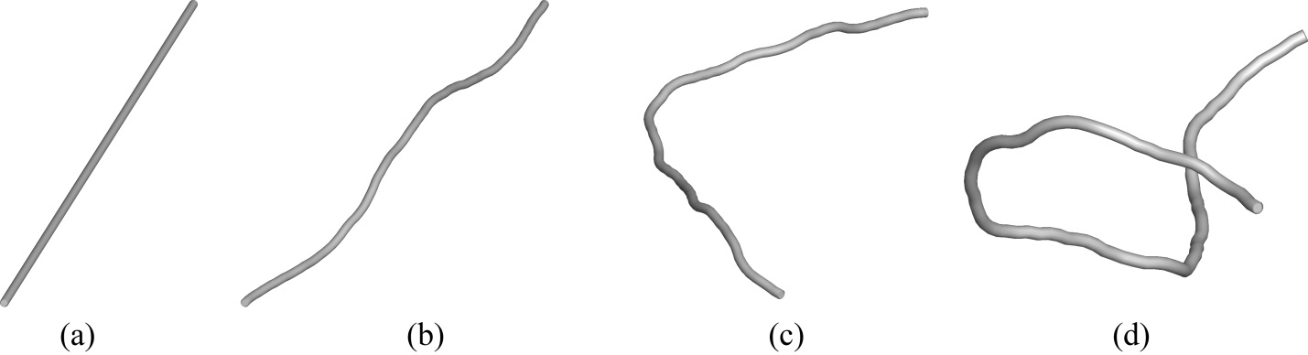

Fig.xxx. CNT samples with different curvatures. (a) Straight CNT $δ=0$. (b) Curved CNT $δ=0.094{nm}^{-1}$. (c) Curved CNT $δ=0.188{nm}^{-1}$. (d) Curved CNT $δ=0.282{nm}^{-1}$.

The periodic boundary conditions are imposed for the RVE, namely the CNT network should repeat periodically in space. To this end, pseudo RVEs surrounding the actual RVE are also created when generating the CNT network. As shown in Fig.xxx(a), the box with solid edges is the actual RVE and other boxes with dashed edges are pseudo RVEs. When adding a new CNT into the network, the copies of this CNT are also added into the pseudo surrounding RVEs. In Figure.xxx(a), the four thick segments are the CNTs added into the actual RVE, and other thin segments are their copies added into the surrounding RVEs. Finally as shown in Fig.xxx(b), the CNT network in the actual RVE must rigorously fulfill the periodic boundary conditions.

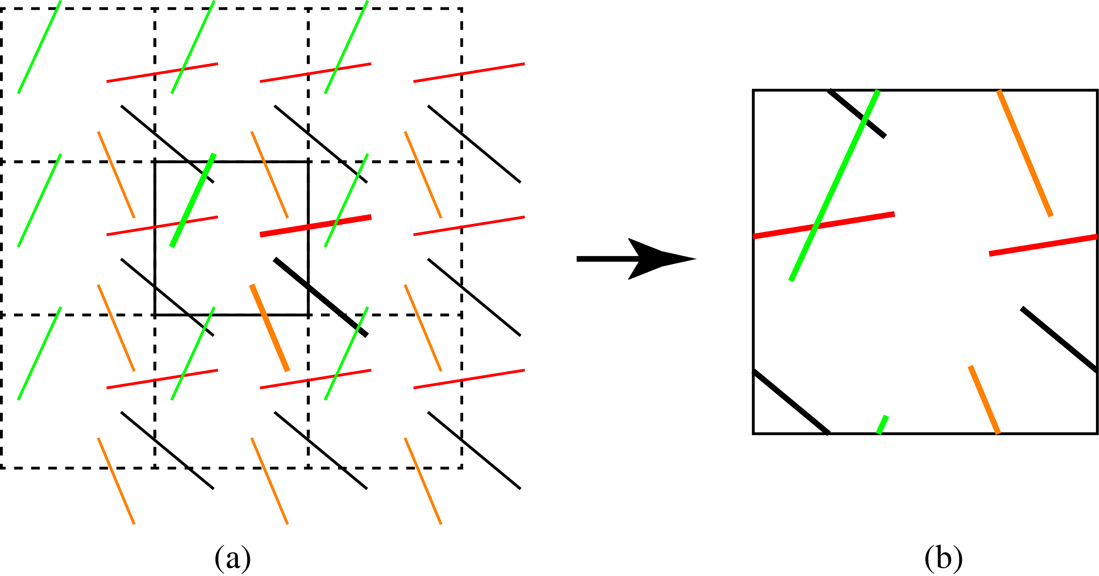

Fig.xxx. The algorithm of imposing the periodic boundary conditions: (a) The box with solid edges is the actual RVE while other boxes with dashed edges are the pseudo RVEs. The four thick segments are the CNTs dispersed into the actual RVE and the thin segments in a same color are the copies of this CNT in pseudo RVEs. (b) The CNT network in the actual RVE must rigorously fulfill the periodic boundary conditions.

In this paper, the CNTs are fully dispersed into the polymer, namely the minimal distance of any two CNTs must larger than $2r_{CNT}+{\text{d}}_{\text{ VDW}}$, where ${\text{d}}_{\text{ VDW}}=\text{0.34} \text{nm}$ is the distance of Van Der Waals force [43]. The distance requirement must be checked when adding a new CNT. In summary, Fig.xxx shows the flowchart of the steps to create a CNT network with periodic boundary conditions.

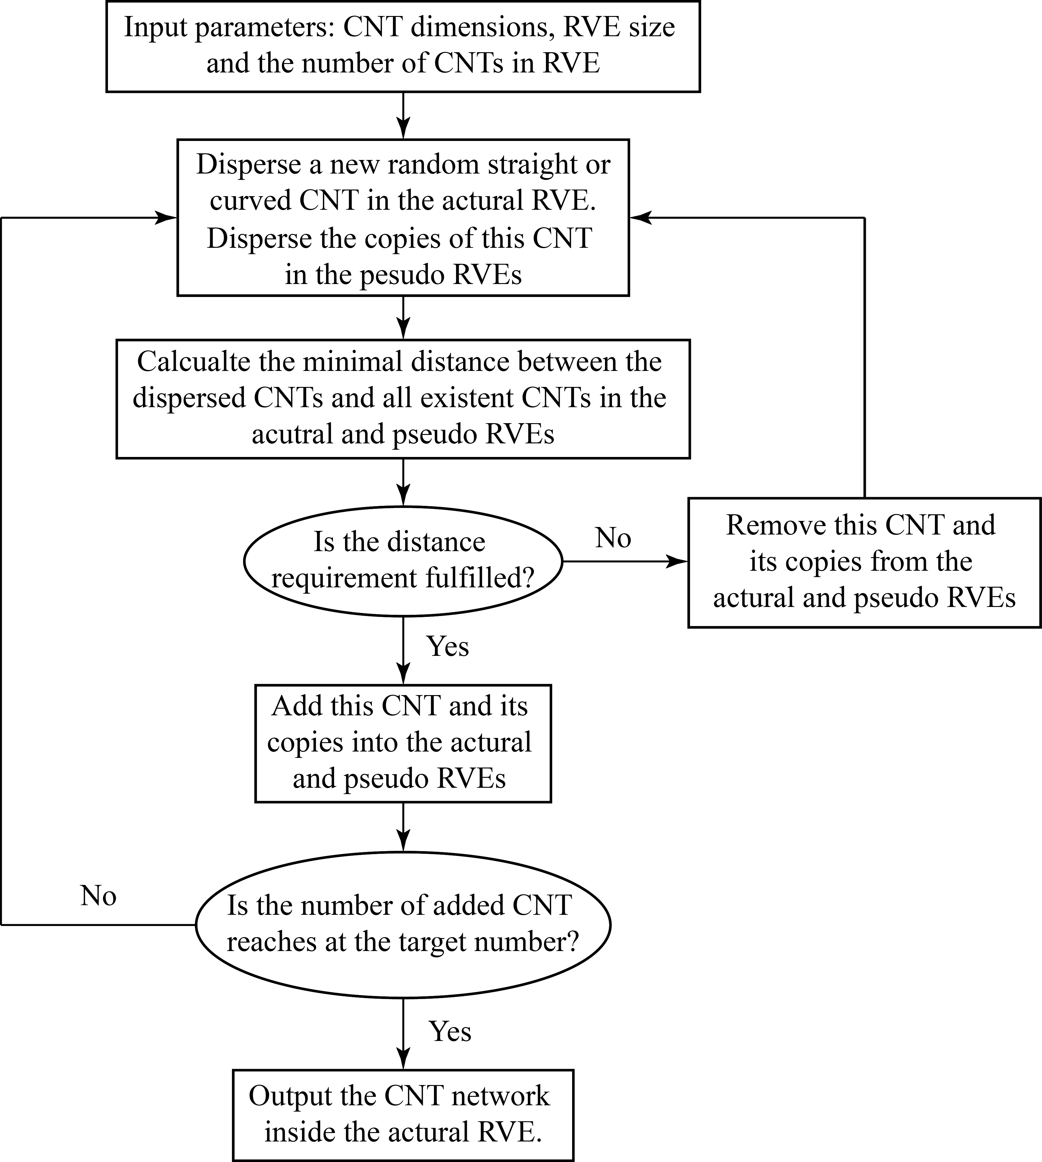

Fig.xxx: The flowchart of steps to create a fully dispersed CNT network with periodic boundary conditions.

1. Validation and numerical results

In this section, two numerical tests are first presented for the validation of the proposed immersed FE approach by comparing its outputs with those obtained with the traditional FE method. The immersed FE method is then used to study the influence of CNT waviness and volume fraction on the elastic properties of their epoxy-based composites.

* 1. Validation of an RVE reinforced with a single CNT

In this example, one SWCNT of (5,5) armchair chirality and of diameter D $\text{= 0.67} \text{nm}$ and length $\text{l}\text{ =10} \text{nm}$ is placed at the center of the polymer matrix. The size of the polymer cell is $\text{7} \text{×} \text{7} \text{×} \text{35} {nm}^{3}$ and the CNT is placed in the center of the polymer as shown in Fig. 4. The material properties of the CNT and polymer were obtained from our previous MD studies [39,49], namely $E_{CNT} \text{=} \text{860} \text{GPa}$, $ν_{CNT} \text{=} \text{0.17}$ and $E_{polymer} \text{=} \text{2.9} \text{GPa}$, $ν_{polymer} \text{=} \text{0.35}$. The following boundary conditions are applied on the FE model: ${\text{d}}_{\text{x}}\text{ = 0}$ at face $\text{x}\text{ = 0}$, ${\text{d}}_{\text{y}}\text{ = 0}$ at face $\text{y}\text{ = 0}$, ${\text{d}}_{z}\text{ = 0}$ at face z $\text{ = 0}$, and ${\text{d}}_{\text{z}}\text{ = 1.75} \text{nm}$ at face $\text{z}\text{ = 35} \text{nm}$.

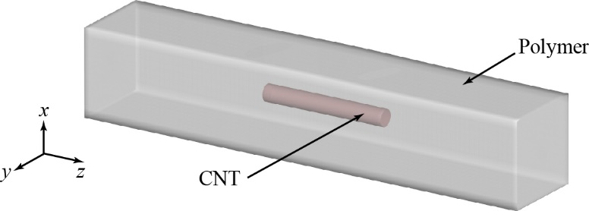

Fig. 4. The model used to verify the proposed immersed FE method: (A) a schematic drawing of a (5,5) CNT of length 10 nm embedded in a polymer cell of square cross-section of 7 nm × 7 nm and length 35 nm, and (b) the applied boundary conditions .

This simple problem is simulated by both traditional and immersed FE methods to determine the validity of the proposed immersed approach for modeling the CNT-epoxy interface and accounting for the reinforcement stiffness in the overall performance of the system. Fig. 5 shows a cross sectional view of the meshed model in the traditional FE simulations, where the elements at the interface are matched. The number of cells in the traditional FEM model is 168300. In the immersed FE model, the CNT grid is similar to the one used in the traditional FEM while the entire box that include the polymer and the CNT is meshed as a regular grid with $\text{30×30×150}$ cells and the material properties of the polymer were assigned to it. The number of cells in these two models is close, so they have a similar grid resolution.

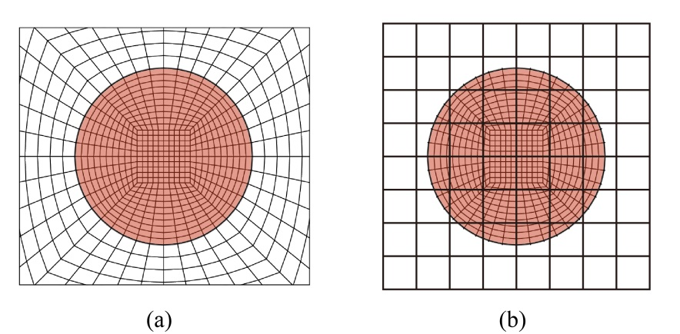

Fig. 5. The CNT and polymer meshes in the area around the CNT in (a) the traditional FE method model, and (b) the Immersed FE method model.

The ${\text{σ}}_{\text{zz}}$ contour of the embedded CNT that were obtained by both modeling techniques are compared in Fig. 6. The ${\text{σ}}_{\text{zz}}$ distribution in Fig. 6(a) and (b) matches well everywhere except the area near the endpoints of the CNT, where they were overestimated in the immersed FE model. The overestimation could occur if a CNT element at the nanotube end are fully located inside a polymer element and it can be eliminated by using a refined polymer grid or a coarser meshing for the CNT. Fig. 6(c) shows the ${\text{σ}}_{\text{zz}}$ contour if the polymer mesh was refined by using $\text{100} \text{×} \text{100} \text{×} \text{500}$ grid. It is very clear that stress concentrations are almost disappeared when we used a much finer mesh that verifies the two conditions mentioned above.

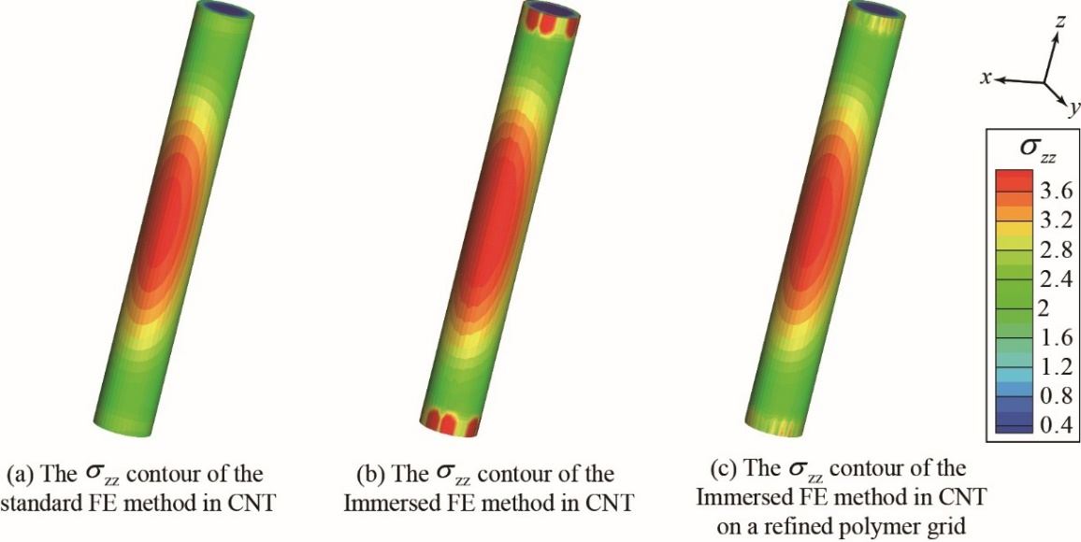  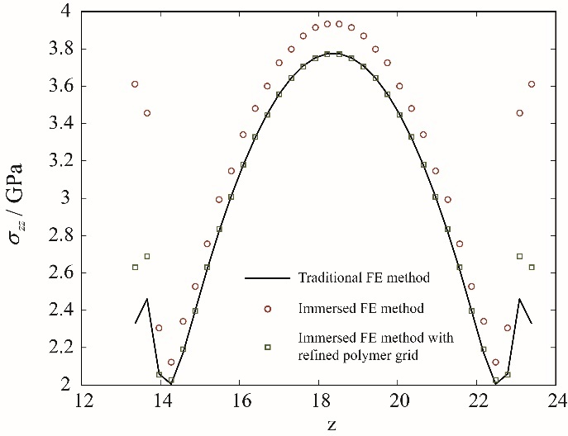

End 2

End 1

Path

(a) (b) (c) (d)

Fig. 6. The ${\text{σ}}_{\text{zz}}$ contours of the CNT obtained by (a) the traditional FE simulations, (b) the immersed FE simulations using a coarse mesh for the polymer, (c) the immersed FE simulations using a finer meshing grid for the polymer, and (d) the variation of ${\text{σ}}_{\text{zz}}$ at the CNT’s surface along the axial direction (the path is shown in fig. 6(a)).

Fig. 7 presents the stress contours in polymer matrix near the embedded CNT that were obtained by the traditional and immersed FE techniques. The stress distribution is very similar in most locations in the polymer in both techniques. The degree of stress concentration near the CNT's endpoints (Saint Venant’s Principle) is underestimated due to the non-matched polymer and CNT grid, and it can also be eliminated by using a refined polymer grid as shown in Fig. 7(c). It should be mentioned that the underestimation is localized because the equilibrium equation has an elliptic form in the immersed FE method. Therefore, it will not result in a sizable error when evaluating the effective material properties of the nanocomposite. Fig. 8 shows the ${\text{σ}}_{\text{zz}}$ contour at the polymer outer boundaries, and the results from the traditional and immersed FE method are almost identical.

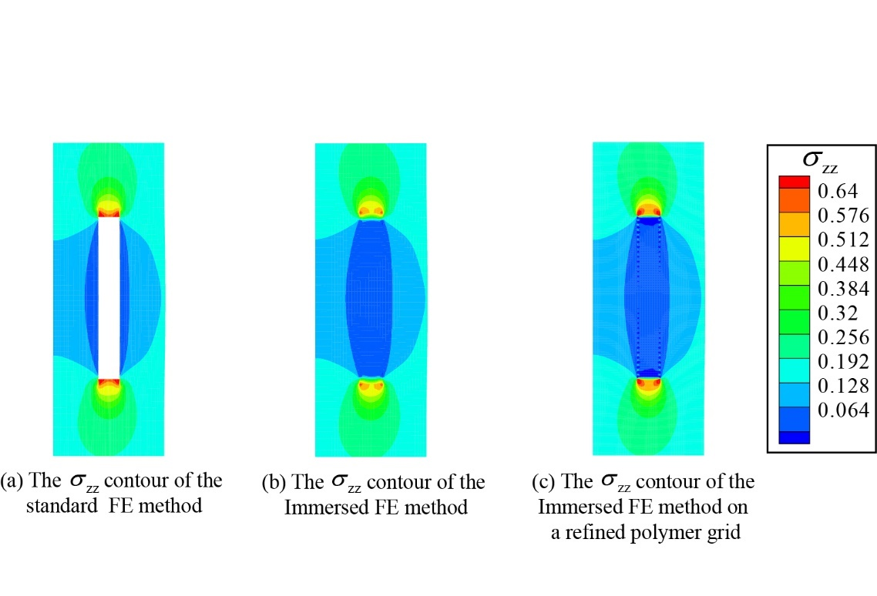   

(a) (b) (c)

Fig. 7. The ${\text{σ}}_{\text{zz}}$ contours of the cross-sectional view in the polymer near the embedded CNT obtained by (a) the traditional FE simulations, (b) the immersed FE simulations using a coarse mesh, (c) the immersed FE simulations using a finer meshing grid.

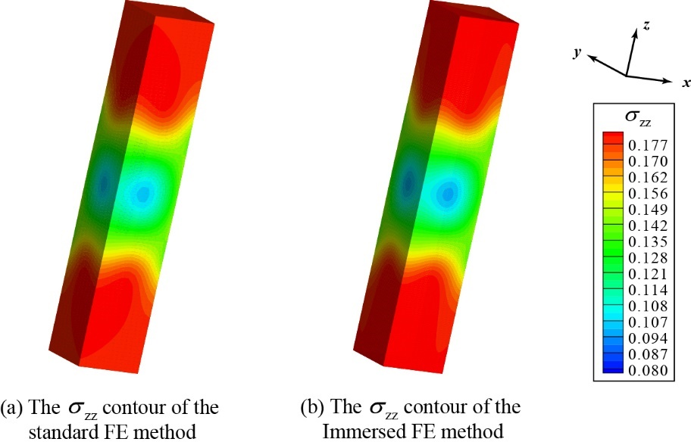  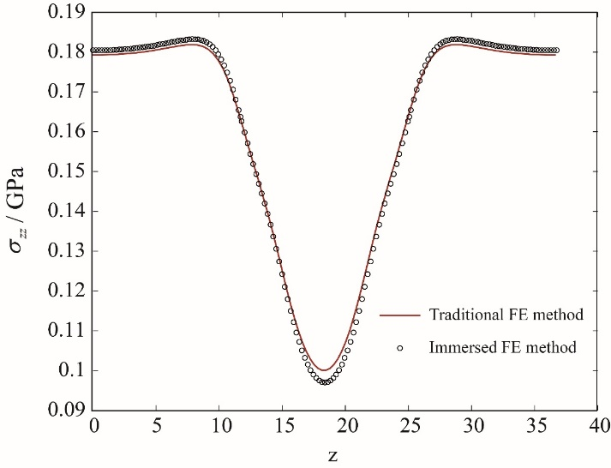

End 2

End 1

Path

(a) (b) (c)

Fig. 8. The ${\text{σ}}_{\text{zz}}$ contours on the boundaries of the polymer cell obtained by (a) the traditional FE simulations, (b) the immersed FE simulations, and (c) the variation of ${\text{σ}}_{\text{zz}}$ at the polymer boundary along the axial direction (the path is shown in fig. 8(a)).

* 1. Validation of an RVE reinforced with randomly dispersed CNTs

In this section, we tested out immersed FE approach against a more complicated problem by modeling RVEs reinforced with randomly dispersed CNTs. In this example, the immersed and traditional FE models of nanocomposites reinforced with different volume fractions are created. The material properties and CNT type are similar to those used in Section ‎3.1. Cubic RVEs of width 70 nm are used in this analysis, where eight different composites are modeled with CNT volume fractions vf varying from 0.025 to 0.2 %. Fig. 9(a), (b), and (c) show the RVEs reinforced with CNT at vf = 0.05, 0.1 and 0.2%, respectively.

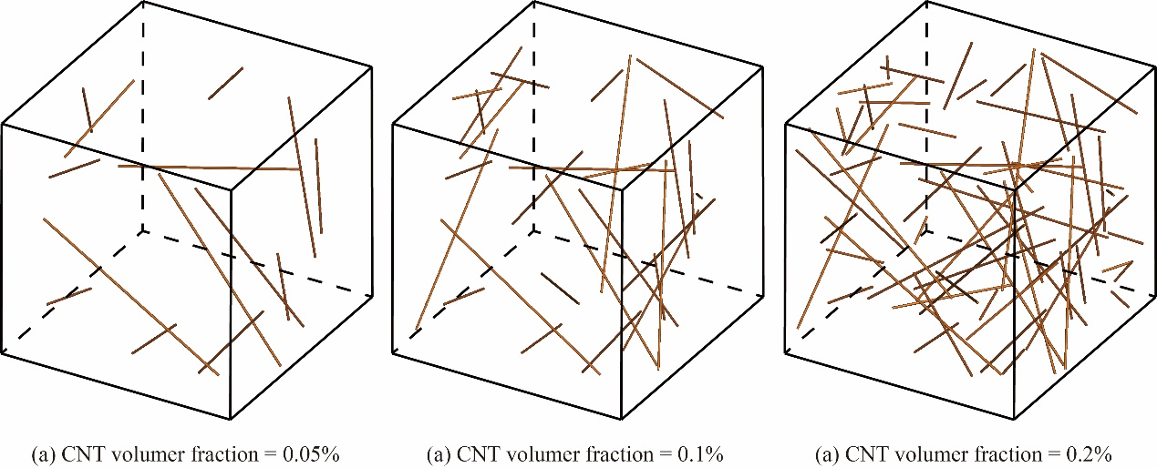  

(a) (b) (c)

Fig. 9. RVEs represent nanocomposites reinforced with CNTs with different volume fractions: (a) vf = 0.05%, (b) vf = 0.1%, and (c) vf = 0.2%,

The elastic moduli ${\text{E}}_{\text{11}}$, ${\text{E}}_{\text{22}}$ and ${\text{E}}_{\text{33}}$ of these RVEs are calculated by the immersed and the traditional FE techniques, and the average Youngs modulus ${\text{E}}_{\text{av}\text{g}}=\left({\text{E}}_{\text{11}}\text{+}{\text{E}}_{\text{22}}\text{+}{\text{E}}_{\text{33}}\right)\text{ / 3}$ from the two methods are compared. The traditional FE models are meshed with 4-node tetrahedron elements. In the immersed FE model, the size of the CNT element is the same with the traditional FE model while the polymer is discretized as regular grid with different resolutions. The polymer grid resolution is defined as

$\text{α = }\frac{d_{CNT}}{{\text{l}}_{polymer}}$ (15)

where $d_{CNT}$ is the diameter of the CNT and ${\text{l}}_{polymer}$ is the length of the polymer element.

Fig. 10 shows the variation of Young’s modulus of the nanocomposite with the CNT volume fraction predicted by the immersed and traditional FE techniques. The results of immersed FE method are dependent on the polymer grid resolution. The difference between the two methods diminishes when a higher grid resolution is used. At resolution $\text{α}=\text{1.0}$, the average Youngs modulus from the immersed and traditional FE method are almost coincident. Fig. 11 shows the variation of the average relative error between the immersed and traditional FE methods with the grid resolution. We can conclude that the results of the immersed FE method can be more accurate by using higher grid resolution for the polymer unit cell.

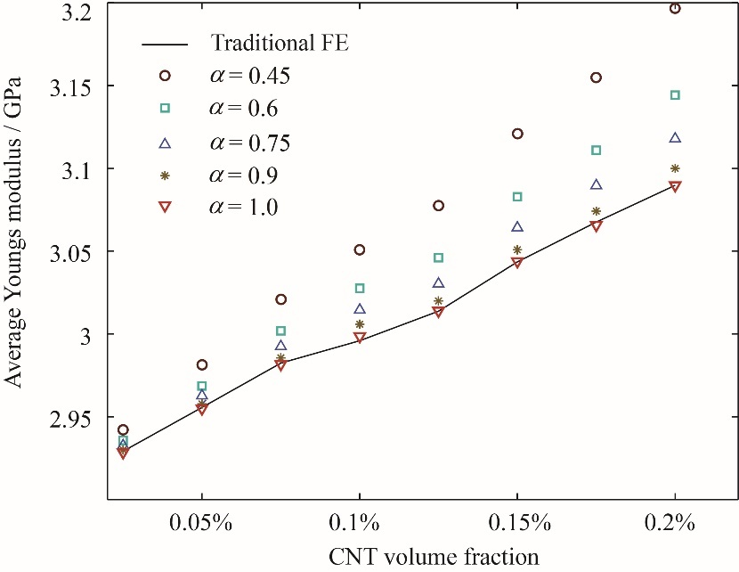

Fig. 10. Comparison of Young’s modulus for nanoreinforced composites containing randomly orientated CNTs obtained with the traditional FE method and the immersed FE method with different polymer grid resolution.

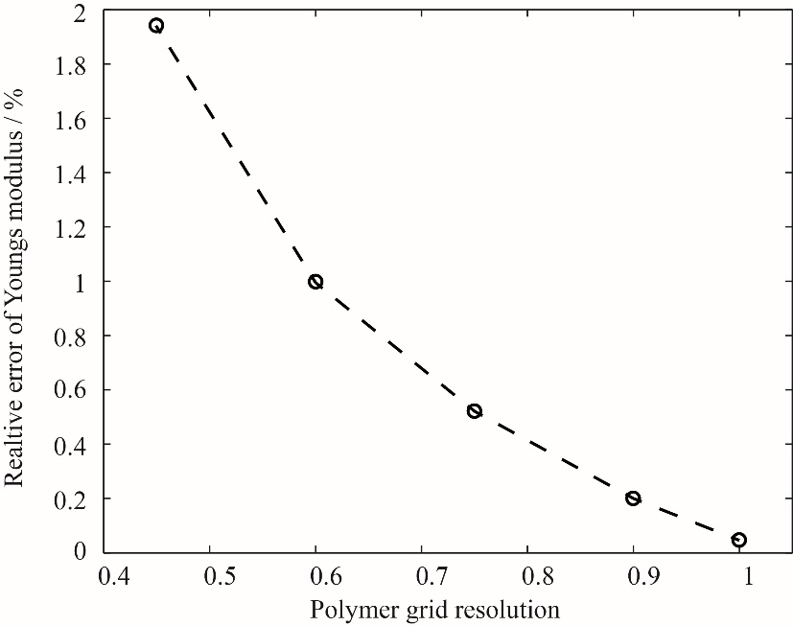

Fig. 11. Variation of relative error of Youngs modulus of CNT-epoxy composites with polymer grid resolution in the immersed FE method.

To demonstrate the advantages of the immersed FE method, Fig. 12 shows the variation of the total number of elements in the immersed and traditional FE models with increasing the CNT volume fraction. The results indicate that the number of elements in the traditional FE method increase 24 times faster than the immersed FE method with increasing the number of dispersed CNTs. In fact, once the polymer grid resolution of the immersed FE model is fixed, the incremental increase in total element number is equal to the elements in the added CNTs that corresponds to the difference in volume fraction. However, in the traditional FE model, the polymer should be re-meshed when adding new CNTs and a lot of new polymer elements are created at the CNT-polymer interface, which leads to a significant increase in the total number of nodes. In addition to the significant increase of computational cost in traditional FE approach, the difficulty in the meshing process also increases dramatically at high CNT volume fractions. The immersed FE method does not face these challenges and provides similar results to the traditional FE method, making it an effective approach to simulate CNT-reinforced nanocomposite with complex morphologies.

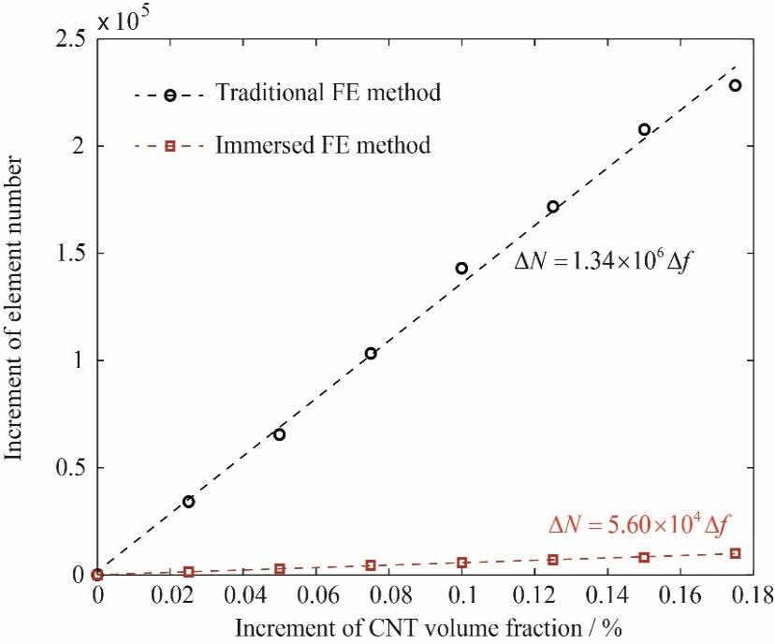

Fig. 12. Variation of the total number of elements in the immersed and traditional FE models with the increase of CNT volume fraction .

* 1. Influence of CNT waviness on material properties of nanocomposites

In this section we used the proposed immersed FE approach in solving complex nanocomposite structures by modeling RVEs reinforced with CNTs of different morphologies. The effect of CNT volume fraction and waviness on the elastic modulus of epoxy-based composites was investigated.

The (5,5) armchair SWCNT with D= 0.67 nm and *l* = 67 nm is selected a reinforcement. These CNTs are uniformly dispersed in a cubic RVE with size *L* = 67 nm. “Fully dispersed” means that all CNTs are randomly distributed inside the RVE and the minimal distance between any two nanotubes must be larger than $D_{CNT} \text{+} {\text{d}}_{\text{ VDW}}$, where ${\text{d}}_{\text{ VDW}}=\text{0.34} \text{nm}$ is the distance of Van Der Waals distance [43].

ADD a description of the curvature parameter δ. We need to include the information of all models in a table. I added one that needed to be made.

In this investigation, three volume fractions ($Vf\text{ = 0.5\%, 1.5\%, 2.5\%}$) are investigated and four curvatures ($\text{δ }\text{= 0} {\text{nm}}^{\text{-1}}\text{, 0.094} {\text{nm}}^{\text{-1}}\text{, 0.188} {\text{nm}}^{\text{-1}}\text{, 0.282} {\text{nm}}^{\text{-1}}$) are considered for each volume fraction. To reduce the effect of the system size and increase the accuracy of the results, for each data point $\left(\text{Vf,δ}\right)$ three RVEs filled with randomly dispersed CNTs are modeled

Periodic boundary condition is applied for enforced on all CNTs crossing the RVE surfaces.

ADD a description of what you mean by periodic boundary conditionso on CNTs. A figure can help + flowchart of the placement steps.

Fig. 13 shows three RVEs reinforced with CNTs of volume fraction $V\text{f}\text{ = 2.5\%}$ and different curvatures. The CNT morphologies in our RVEs are very similar to the microstructure of actual nanocomposites as imaged with scanning electron microscopy [35] (see Fig. 13(d)). The polymer grid resolution for the polymer matrix was selected to be $\text{ 1}$ for all cases.

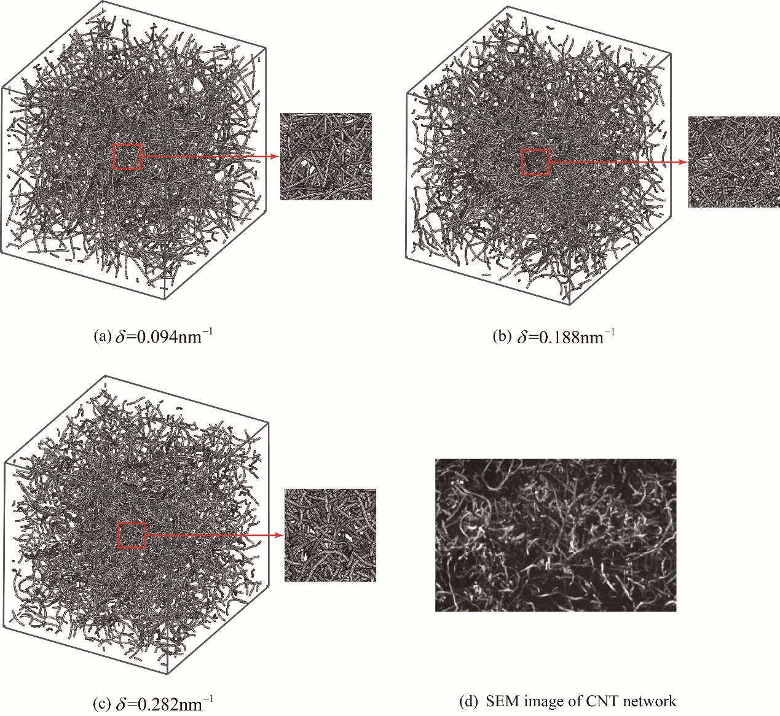

Figure.13: The curved CNT nets with different curvatures include a curved CNT beside each RVE and enlarge the enlarged part to show individual CNTs.

Figs. 14 and 15 show the variation of Young’s modulus of the nanocomposites with increasing the CNT curvature and volume fraction, respectively. The effective Young’s modulus at each combination $\left(\text{v}\text{f , }\text{δ}\right)$ is the average of 3 different simulations. Fig. 14 indicates that the effective Young’s modulus decreases with increasing CNT curvature. This result is in agood agreement with those obtained in the literature with atomistic and analytical techniques [34–36,50]. The numerical results are also compared with the experimental results of CNT–epoxy composites [51] and the obtained elastic moduli at waviness ration $\text{δ }\text{= 0}{\text{.188} \text{nm}}^{\text{-1}}$ matches well with the experimental data. The good agreement between the reported experimental data and the numerical results also validates the capability of the proposed method in modeling actual nanocomposite materials.

I think you should include some numbers her. The elastic modulus is xxx GPa and increased by 70% when the volume fraction of CNT increased to xxx %. Furthermore, the elastic modulus decreased significantly and lost half of its strength when the waviness ratio increased to XXXX,

Additionally, Fig. 15 demonstrates that the decrement of effective Young’s modulus is almost linear from $\text{δ }\text{= 0}{ \text{nm}}^{\text{-1}}$ to $\text{δ }\text{= 0.282} {\text{nm}}^{\text{-1}}$ and the slopes for $V\text{f}\text{ = 0.5\%, 1.5\%, 2.5\%}$ are $\text{-0.87}$, $\text{-2.41}$ and $\text{-3.12}$, respectively. These results demonstrate that the reduction of Young’s modulus becomes more tangible at higher CNT volume fractions and this conclusion is in agreement with the study by Roham [41].

Table 1. The details of the

|  |  |  |  |  |  |
| --- | --- | --- | --- | --- | --- |
|  | CNT Vf (%) | # CNTs | Waviness ratio | # elements | # nodes |
| Case #1 |  |  |  |  |  |
| Case #2 |  |  |  |  |  |
| Case #3 |  |  |  |  |  |
| Case #4 |  |  |  |  |  |

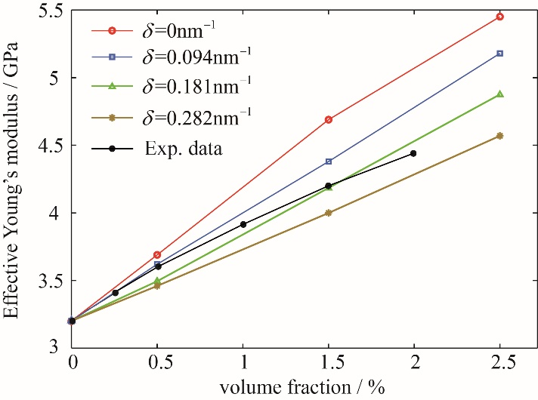

Fig. 14. Variation of the effective Young’s modulus of CNT-epoxy composites with increasing the volume fraction of CNTs of different curvatures.

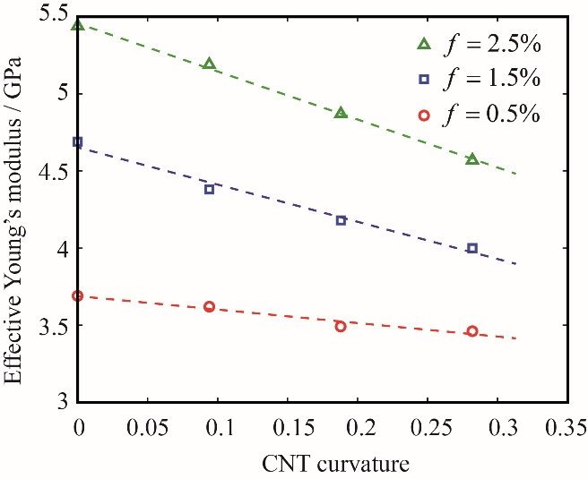

Fig. 15. Variation of the effective Young’s modulus of CNT-epoxy composites with increasing the curvature ratio of the CNTs obtained for at different CNTs volume fractions.

1. Conclusion

In this study, we developed a modeling approach based on the immersed finite element method to determine the mechanical properties of CNT-reinforced polymer composites. In this model, the dispersed CNTs and the surrounding polymer matrix were created independently but simulated as a coupled system. The nanocomposite model can be easily created by eliminating the associated difficulties in creating a compatible mesh and reducing the computational cost faced in the traditional finite element method. When coupling the independent CNT and polymer grids, both kinematic and mechanic relations in between are considered in the analysis by embedding the equilibrium equation of each CNT into the equilibrium equation of the polymer. Since no additional unnecessary assumptions are introduced, the results of the immersed FE method are very close to the traditional FE method.

Include the meshing control condition to obtain good results (parameter =1)

The proposed method is used to study the influence of CNT waviness on Young’s modulus of CNT-epoxy composites. The morphology of CNTs in our study is very similar to actual nanocomposites and the numerical results indicate that the CNT waviness deteriorates the performance of the material.

Include few numbers here for the obtained properties

The numerical results show good agreements with previous experimental and numerical studies, thus validating the capability of the immersed FE technique in simulating realistic composites with complex microstructures.

Reference

[1] A. Krishnan, E. Dujardin, T.W. Ebbesen, P.N. Yianilos, M.M.J. Treacy, Young’s modulus of single-walled nanotubes, Phys. Rev. B. 58 (1998) 14013–14019. doi:10.1103/PhysRevB.58.14013.

[2] B.I. Yakobson, C.J. Brabec, J. Bernholc, Nanomechanics of Carbon Tubes: Instabilities beyond Linear Response, Phys. Rev. Lett. 76 (1996) 2511–2514. doi:10.1103/PhysRevLett.76.2511.

[3] E.W. Wong, Nanobeam Mechanics: Elasticity, Strength, and Toughness of Nanorods and Nanotubes, Science. 277 (1997) 1971–1975. doi:10.1126/science.277.5334.1971.

[4] M.M.J. Treacy, T.W. Ebbesen, J.M. Gibson, Exceptionally high Young’s modulus observed for individual carbon nanotubes, Nature. 381 (1996) 678–680. doi:10.1038/381678a0.

[5] J. Hone, M. Whitney, C. Piskoti, A. Zettl, Thermal conductivity of single-walled carbon nanotubes, Phys. Rev. B. 59 (1999) 2514–2516. doi:10.1103/PhysRevB.59.R2514.

[6] S.J. Tans, M.H. Devoret, H. Dai, A. Thess, R.E. Smalley, L.J. Geerligs, C. Dekker, Individual single-wall carbon nanotubes as quantum wires, Nature. 386 (1997) 474.

[7] T.W. Odom, J.-L. Huang, P. Kim, C.M. Lieber, Atomic structure and electronic properties of single-walled carbon nanotubes, Nature. 391 (1998) 62.

[8] S. Berber, Y.-K. Kwon, D. Tománek, Unusually High Thermal Conductivity of Carbon Nanotubes, Phys. Rev. Lett. 84 (2000) 4613–4616. doi:10.1103/PhysRevLett.84.4613.

[9] J.N. Coleman, U. Khan, W.J. Blau, Y.K. Gun’ko, Small but strong: A review of the mechanical properties of carbon nanotube–polymer composites, Carbon. 44 (2006) 1624–1652. doi:10.1016/j.carbon.2006.02.038.

[10] M.F.L.D. Volder, S.H. Tawfick, R.H. Baughman, A.J. Hart, Carbon Nanotubes: Present and Future Commercial Applications, Science. 339 (2013) 535–539. doi:10.1126/science.1222453.

[11] N. Lachman, H. Daniel Wagner, Correlation between interfacial molecular structure and mechanics in CNT/epoxy nano-composites, Compos. Part Appl. Sci. Manuf. 41 (2010) 1093–1098. doi:10.1016/j.compositesa.2009.08.023.

[12] S. Ganguli, M. Bhuyan, L. Allie, H. Aglan, Effect of multi-walled carbon nanotube reinforcement on the fracture behavior of a tetrafunctional epoxy, J. Mater. Sci. 40 (2005) 3593–3595. doi:10.1007/s10853-005-2891-x.

[13] J. Nafar Dastgerdi, G. Marquis, M. Salimi, Micromechanical modeling of nanocomposites considering debonding and waviness of reinforcements, Compos. Struct. 110 (2014) 1–6. doi:10.1016/j.compstruct.2013.11.017.

[14] L.H. Shao, R.Y. Luo, S.L. Bai, J. Wang, Prediction of effective moduli of carbon nanotube–reinforced composites with waviness and debonding, Compos. Struct. 87 (2009) 274–281. doi:10.1016/j.compstruct.2008.02.011.

[15] E.T. Thostenson, T.-W. Chou, On the elastic properties of carbon nanotube-based composites: modelling and characterization, J. Phys. Appl. Phys. 36 (2003) 573–582. doi:10.1088/0022-3727/36/5/323.

[16] A.R. Alian, S.A. Meguid, Large-Scale Atomistic Simulations of CNT-Reinforced Thermoplastic Polymers, Compos. Struct. 191 (2018) 221–230. doi:10.1016/j.compstruct.2018.02.056.

[17] M. Griebel, J. Hamaekers, Molecular dynamics simulations of the elastic moduli of polymer–carbon nanotube composites, Comput. Methods Appl. Mech. Eng. 193 (2004) 1773–1788. doi:10.1016/j.cma.2003.12.025.

[18] S.C. Chowdhury, T. Okabe, Computer simulation of carbon nanotube pull-out from polymer by the molecular dynamics method, Compos. Part Appl. Sci. Manuf. 38 (2007) 747–754. doi:10.1016/j.compositesa.2006.09.011.

[19] S. Frankland, The stress–strain behavior of polymer–nanotube composites from molecular dynamics simulation, Compos. Sci. Technol. 63 (2003) 1655–1661. doi:10.1016/S0266-3538(03)00059-9.

[20] A.R. Alian, S.A. Meguid, Multiscale Modeling of Nanoreinforced Composites, in: S.A. Meguid (Ed.), Adv. Nanocomposites, Springer International Publishing, Cham, 2016: pp. 1–39. http://link.springer.com/10.1007/978-3-319-31662-8_1 (accessed June 23, 2016).

[21] Y. Han, J. Elliott, Molecular dynamics simulations of the elastic properties of polymer/carbon nanotube composites, Comput. Mater. Sci. 39 (2007) 315–323. doi:10.1016/j.commatsci.2006.06.011.

[22] S. Frankland, The stress–strain behavior of polymer–nanotube composites from molecular dynamics simulation, Compos. Sci. Technol. 63 (2003) 1655–1661. doi:10.1016/S0266-3538(03)00059-9.

[23] G.D. Seidel, D.C. Lagoudas, Micromechanical analysis of the effective elastic properties of carbon nanotube reinforced composites, Mech. Mater. 38 (2006) 884–907. doi:10.1016/j.mechmat.2005.06.029.

[24] J.M. Haile, Molecular dynamics simulation: elementary methods, Wiley, New York, 1992.

[25] A.R. Alian, S.I. Kundalwal, S.A. Meguid, Interfacial and mechanical properties of epoxy nanocomposites using different multiscale modeling schemes, Compos. Struct. 131 (2015) 545–555. doi:10.1016/j.compstruct.2015.06.014.

[26] H. Chen, Q. Xue, Q. Zheng, J. Xie, K. Yan, Influence of Nanotube Chirality, Temperature, and Chemical Modification on the Interfacial Bonding between Carbon Nanotubes and Polyphenylacetylene, J. Phys. Chem. C. 112 (2008) 16514–16520. doi:10.1021/jp803615v.

[27] T. Xiao, K. Liao, A nonlinear pullout model for unidirectional carbon nanotube-reinforced composites, Compos. Part B Eng. 35 (2004) 211–217. doi:10.1016/j.compositesb.2003.08.001.

[28] S.J.V. Frankland, A. Caglar, D.W. Brenner, M. Griebel, Molecular Simulation of the Influence of Chemical Cross-Links on the Shear Strength of Carbon Nanotube−Polymer Interfaces, J. Phys. Chem. B. 106 (2002) 3046–3048. doi:10.1021/jp015591+.

[29] V. Lordi, N. Yao, Molecular mechanics of binding in carbon-nanotube–polymer composites, J. Mater. Res. 15 (2000) 2770–2779. doi:10.1557/JMR.2000.0396.

[30] D.-L. Shi, X.-Q. Feng, H. Jiang, Y.Y. Huang, K.-C. Hwang, Multiscale Analysis of Fracture of Carbon Nanotubes Embedded in Composites, Int. J. Fract. 134 (2005) 369–386. doi:10.1007/s10704-005-3073-1.

[31] K.S. Khare, R. Khare, Effect of Carbon Nanotube Dispersion on Glass Transition in Cross-Linked Epoxy–Carbon Nanotube Nanocomposites: Role of Interfacial Interactions, J. Phys. Chem. B. 117 (2013) 7444–7454. doi:10.1021/jp401614p.

[32] Q. Jiang, S.S. Tallury, Y. Qiu, M.A. Pasquinelli, Molecular dynamics simulations of the effect of the volume fraction on unidirectional polyimide–carbon nanotube nanocomposites, Carbon. 67 (2014) 440–448. doi:10.1016/j.carbon.2013.10.016.

[33] F.F. Abraham, R. Walkup, H. Gao, M. Duchaineau, T. Diaz De La Rubia, M. Seager, Simulating materials failure by using up to one billion atoms and the world’s fastest computer: Work-hardening, Proc. Natl. Acad. Sci. 99 (2002) 5783–5787. doi:10.1073/pnas.062054999.

[34] F.T. Fisher, R.D. Bradshaw, L.C. Brinson, Effects of nanotube waviness on the modulus of nanotube-reinforced polymers, Appl. Phys. Lett. 80 (2002) 4647–4649. doi:10.1063/1.1487900.

[35] F. Fisher, Fiber waviness in nanotube-reinforced polymer composites—I: Modulus predictions using effective nanotube properties, Compos. Sci. Technol. 63 (2003) 1689–1703. doi:10.1016/S0266-3538(03)00069-1.

[36] D. Savvas, G. Stefanou, V. Papadopoulos, M. Papadrakakis, Effect of waviness and orientation of carbon nanotubes on random apparent material properties and RVE size of CNT reinforced composites, Compos. Struct. 152 (2016) 870–882. doi:10.1016/j.compstruct.2016.06.009.

[37] H.R. Lusti, A.A. Gusev, Finite element predictions for the thermoelastic properties of nanotube reinforced polymers, Model. Simul. Mater. Sci. Eng. 12 (2004) S107–S119. doi:10.1088/0965-0393/12/3/S05.

[38] J.M. Wernik, S.A. Meguid, Multiscale micromechanical modeling of the constitutive response of carbon nanotube-reinforced structural adhesives, Int. J. Solids Struct. 51 (2014) 2575–2589. doi:10.1016/j.ijsolstr.2014.03.009.

[39] A.R. Alian, S.I. Kundalwal, S.A. Meguid, Multiscale modeling of carbon nanotube epoxy composites, Polymer. 70 (2015) 149–160. doi:10.1016/j.polymer.2015.06.004.

[40] T. Mori, K. Tanaka, Average stress in matrix and average elastic energy of materials with misfitting inclusions, Acta Metall. 21 (1973) 571–574. doi:10.1016/0001-6160(73)90064-3.

[41] R. Rafiee, Influence of carbon nanotube waviness on the stiffness reduction of CNT/polymer composites, Compos. Struct. 97 (2013) 304–309. doi:10.1016/j.compstruct.2012.10.028.

[42] N. Marzari, M. Ferrari, Textural and Micromorphological Effects on the Overall Elastic Response of Macroscopically Anisotropic Composites, J. Appl. Mech. 59 (1992) 269. doi:10.1115/1.2899516.

[43] A.R. Alian, S.A. Meguid, Multiscale modeling of the coupled electromechanical behavior of multifunctional nanocomposites, Compos. Struct. 208 (2019) 826–835. doi:10.1016/j.compstruct.2018.10.066.

[44] D. Weidt, Ł. Figiel, Effect of CNT waviness and van der Waals interaction on the nonlinear compressive behaviour of epoxy/CNT nanocomposites, Compos. Sci. Technol. 115 (2015) 52–59. doi:10.1016/j.compscitech.2015.04.018.

[45] K. Grabowski, P. Zbyrad, T. Uhl, W.J. Staszewski, P. Packo, Multiscale electro-mechanical modeling of carbon nanotube composites, Comput. Mater. Sci. 135 (2017) 169–180. doi:10.1016/j.commatsci.2017.04.019.

[46] X.L. Chen, Y.J. Liu, Square representative volume elements for evaluating the effective material properties of carbon nanotube-based composites, Comput. Mater. Sci. 29 (2004) 1–11. doi:10.1016/S0927-0256(03)00090-9.

[47] M. Karimi, A. Montazeri, R. Ghajar, On the elasto-plastic behavior of CNT-polymer nanocomposites, Compos. Struct. 160 (2017) 782–791. doi:10.1016/j.compstruct.2016.10.053.

[48] T.-W. Chou, Microstructural design of fiber composites, Cambridge University Press, Cambridge ; New York, 2005.

[49] A.R. Alian, S.A. Meguid, S.I. Kundalwal, Unraveling the influence of grain boundaries on the mechanical properties of polycrystalline carbon nanotubes, Carbon. 125 (2017) 180–188. doi:10.1016/j.carbon.2017.09.056.

[50] A.R. Alian, S. El-Borgi, S.A. Meguid, Multiscale modeling of the effect of waviness and agglomeration of CNTs on the elastic properties of nanocomposites, Comput. Mater. Sci. 117 (2016) 195–204. doi:10.1016/j.commatsci.2016.01.029.

[51] M. Omidi, H. Rokni D.T., A.S. Milani, R.J. Seethaler, R. Arasteh, Prediction of the mechanical characteristics of multi-walled carbon nanotube/epoxy composites using a new form of the rule of mixtures, Carbon. 48 (2010) 3218–3228. doi:10.1016/j.carbon.2010.05.007.